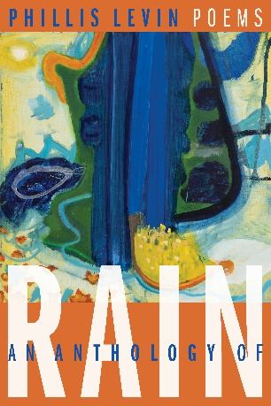
An Anthology of Rain: Poems
New Book by Acclaimed Poet
Phillis Levin

Phillis Levin’s much-anticipated sixth collection, An Anthology of Rain, is a series of poems immersed in time while acknowledging “How it is / Is not how it is / It keeps changing.” Memories become palpable as the present: a duel of roses between friends and across languages is cause for delight, as is the vision of a father returned to life to assuage the poet’s grief. Light and water are twin elements, whether the “Blighted light” of a leaf turning in early fall or a drop of rain inviting us to trace its movement down a window. A spirit of reciprocity between poet and reader animates this collection, creating what the best poems offer—a thrilling sense of immediacy in the face of flux.

Praise for An Anthology of Rain

“Phillis Levin’s poetry has been characterized over the past thirty years by an astonishingly consistent excellence. She has written, again and again, across a half-dozen books, poems that are precise, feeling-full and piercing, elegant, informed and aware of the world, and rich in the kind of profound play that is a hallmark of real art.” –Vijay Seshadri

“In this stunning new collection, An Anthology of Rain, the insightful observation of Phillis Levin is at its full
power. Elegantly understated, there’s a lyric intensity here that reminds us of how closely beauty and heartbreak can co-exist…. Like many of her poems over her impressive career, these poems reveal what we needed to see—not simply around us but within us—all along, ‘as if breaking a spell.’ Yeah, that’s ‘how it is.’” –A. Van Jordan

“As only supreme artistry can achieve. Phillis Levin has long been one of our purest masters of lyric form, and in this ravishing new collection she bids us welcome to a realm of solace and enchantment.”
–Linda Gregerson

about the poet
Phillis Levin is the author of Mr. Memory & Other Poems, a finalist for the 2016 Los Angeles Times Book Prize; May Day; Mercury; The Afterimage; and Temples and Fields, winner of the Poetry Society of America’s Norma Farber First Book Award. She is the editor of The Penguin Book of the Sonnet. She lives with her husband in New York City.

Publication date: April 15, 2025
Price: $18.00 paperback, $9.99 ebook
ISBN 978-1-962131-06-3 (paperback)
ISBN 978-1-962131-08-7 (ebook)
6 x 9 * 90 pages * Poetry
BISAC POE024000 (Poetry/Women Authors)
BISAC POE000000 (Poetry/General)
Publisher: Barrow Street Press
Website: https://barrowstreet.org/press/
Distributor: Itasca Books
Order from Ingram, Baker & Taylor
Rights Available: Translation, International
Literary Agent: Kathleen Anderson
kathleen@andersonliterary.org
Review copies, media & speaker requests:
Mantra Public Relations, +1-212-645-1600
gaye@mantrapublicrelations.com
christi@mantrapublicrelations.com

BARROW STREET

